

|  |
| --- |
| C.P.N.M. LAB REPORT |
|  |
| ASSIGNMENT 2  BCSE FIRST YEAR FIRST SEMESTER  Authored by: SOHAM CHOWDHURY |

# logo-placeholder

**CPNM LAB ASSIGNMENT REPORT**

BCSE FIRST YEAR FIRST SEMESTER 2021-2022

NAME-SOHAM CHOWDHURY

DEPARTMENT-COMPUTER SCIENCE AND ENGINEERING

SECTION-A3.

ROLL NO-002110501145.

# ASSIGNMENT 2

1.Write a C program that reads two values from the keyboard, swaps their values and prints out the result.

Here, we performed swapping without using third variable.

#include<stdio.h>

int main ()

{

    int a,b;

    printf("enter the two numbers respectively\n");

    scanf("%d%d",&a,&b);

    a=a+b;

    b=a-b;

    a=a-b;

    printf("the new swaped values respectively are  %d and %d",a,b);

    return 0;

}

OUTPUT-

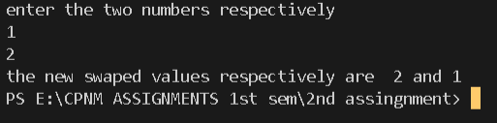

2.If a three-digit integer is input through the keyboard, write a program to calculate the sum of its digits. (Hint: Use the modulo operator ‘%’)

HERE,we used the logic of using digit extraction using modulus operator then storing the digits sum in a variable.

#include<stdio.h>

void main()

{

    int a,i,d,sum=0;

    printf("enter the three digit number");

    scanf("%d",&a);

    for(i=a;i>0;i/=10)

    {

        d=i%10;

        sum=sum+d;

    }

    printf("sum of digits is %d",sum);

}

OUTPUT-



3. Input two integer numbers and divide the larger number by the smaller one. Then display the result using printf() function as a fractional number first and then as a real valued number. (Example: 9 divided by 5 shall yield “ 4/5” and “1.8” respectively. )

HERE,we found the number which is smaller and greater among the two numbers given by the user as input and then printed the division resultant in float and fraction was obtained by the remainder remainder found by using modulus operation among the two numbers.

#include<stdio.h>

#include<math.h>

void main()

{

    int n1,n2,remainder;

    printf("enter the two number");

    scanf("%d%d",&n1,&n2);

    if(n1>n2)

    {

        remainder=n1%n2;

        printf("%d/%d\n",remainder,n2);

        printf("%f",(float)n1/n2);

    }

    else

    {

        remainder=n2%n1;

        printf("%d/%d\n",remainder,n1);

        printf("%f",(float)(n2/n1));

    }

}

OUTPUT-

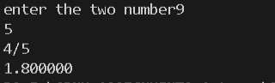

4. Write a C program which accepts basic salary as input and prints the gross salary, which is the sum of the basic, dearness allowance (60% of basic salary), and house rent allowance (15% of basic salary).

Here,we just took the basic salary of the employee from the user and expressed dearness allowance in terms of the basic salary then just printed it.

#include<stdio.h>

void main()

{

    int basic_salary;

    printf("enter the basic salary");

    scanf("%d",&basic_salary);

    printf("the gross salary is %f",(float)(basic_salary+0.6*basic_salary+0.15*basic_salary));

}

OUTPUT-



5. Any year is input through the keyboard. Write a program to determine whether the year is a leap year or not. (Hint: Use the % (modulus) operator)

WE TAKE THE YEAR AS INPUT FROM THE USER THEN IF IT IS DIVISIBLE BY 4 THEN LEAP YEAR ELSE NOT A LEAP YEAR.

#include<stdio.h>

int main()

{

    int year;

    printf("enter the year = ");

    scanf("%d",&year);

    if(year%4==0)

    printf("it is a leap year");

    else

    printf("not a leap year");

    return 0;

}

OUTPUT-



6. Write a program to check whether a triangle is valid or not, when (i) the three angles of the triangle are entered through the Keyboard (ii) three sides of the triangle are entered through the keyboard.

WE TAKE SIDES OR ANGLES AS INPUT AND IF THE SUM OF ALL ANGLES IS EQUAL TO 180 OR IF SUM OF TWO SIDES IS GREATER THAN THE THIRD THEN THE TRIANGLE EXISTS.

#include<stdio.h>

int main()

{

    int s;

    printf("enter the choice");

    scanf("%d",&s);

    int a,b,c;

    switch (s)

    {

        case 1:

        printf("enter the three angles ");

        scanf("%d%d%d",&a,&b,&c);

        if((a+b+c==180)&&(a>0)&&(b>0)&&(c>0))

        printf("valid triangle");

        break;

        case 2:

        printf("enter the three sides ");

        scanf("%d%d%d",&a,&b,&c);

        if((a+b>c||a+c>b||b+c>a)&&(a>0)&&(b>0)&&(c>0))

        printf("valid triangle");

        break;

        default:

        printf("invalid choice");

        return 0;

    }

}

OUTPUT-

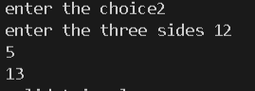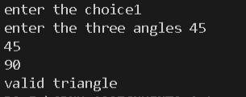

7. Given three points (x1, y1), (x2, y2) and (x3, y3), write a program to check if all the three points fall on one straight line.

TO CHECK WHETER THREE POINTS LIE IN THE SAME LINE I CHECKED THE SLOPE BETWEEN TWO POINTS AND COMPARED IT WITH THE SLOPE BETWEEN AND OF THE ONE POINTS WITH THE THIRD POINT.

#include<stdio.h>

void main()

{

    int x1,x2,x3,y1,y2,y3;

    printf("enter the 1st coordinate ");

    scanf("%d%d",&x1,&y1);

    fflush(stdin);

    printf("enter the 2nd coordinate ");

    scanf("%d%d",&x2,&y2);

    fflush(stdin);

    printf("enter the 3rd coordinate ");

    scanf("%d%d",&x3,&y3);

    if((float)((y2-y1)/(x2-x1))==(float)((y3-y2)/(x3-x2))||(float)((y2-y1)/(x2-x1))==-(float)((y3-y2)/(x3-x2)))

    printf("they are in a straight line");

    else

    printf("they are not in a straight line");

}

OUTPUT-

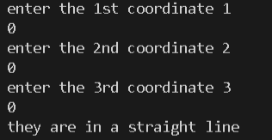

8. Given the coordinates (x, y) of a center of a circle and its radius, write a program which will determine whether a point lies inside the circle, on the circle or outside the circle. (Hint: #include . Use sqrt( ) and pow( ) functions)

Here I use the distance formula between an arbitrary point defined by the user and the centre of the circle which was also defined by the user and if it was greater than radius of the circle then point lies outside,if equal to radius then point lies on the circle,else inside the circle.

#include<stdio.h>

#include<math.h>

void main()

{

    int x,y,r,x1,y1;

    double resultant;

    printf("enter the center of the circle ");

    scanf("%d%d",&x,&y);

    printf("enter the radius");

    scanf("%d",&r);

    printf("enter the point you want to check");

    scanf("%d%d",&x1,&y1);

    resultant = pow(x-x1,2)+pow(y-y1,2)-r*r;

    if(resultant==0)

    printf("point lies on the circle");

    else if(resultant>0)

    printf("the point lies outside the circle");

    else

    printf("point lies inside the circle");

}

OUTPUT-

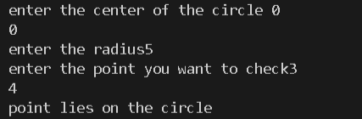

9. Any character is entered through the keyboard, write a program to determine whether the character entered is a capital letter, a small case letter, a digit or a special symbol.

HERE I USED THE CONCEPT OF ASCII VALUES TO FIND OUT THE TYPE OF CHARACTERS GIVEN AS INPUT FROM THE USER.

#include<stdio.h>

int main()

{

    char c;

    printf("enter character ");

    scanf("%c",&c);

    if((int)c>=65&&(int)c<=90)

    printf("upper case");

    else if((int)c>=97&&(int)c<=122)

    printf("lower case");

    else if((int)c>=48&&(int)c<=57)

    printf("digit");

    else

    {

        if((int)c>32)

        printf("special character");

    }

    return 0;

}

OUTPUT-

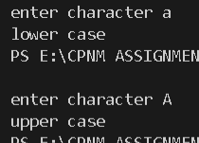

10. Given as input an integer number of seconds, write a program to print as output the equivalent time in hours, minutes and seconds. Recommended output format is something like 7322 seconds is equivalent to 2 hours 2 minutes 2 seconds

WE FIRST CHECK WHETHER THE SECONDS GIVEN BY USER IS EQUIVALENT TO HOURS MINUTES OR SECOND THEN CALCULATE THE NUMBER OF HOURS THEN SECONDS THEN MINUTES AND PRINT THEM.

#include<stdio.h>

int main()

{

    int t,hr,min,sec,remainder;

    printf("enter the seconds");

    scanf("%d",&t);

    if(t>3600)

    {

        hr=t/3600;

        t=t%3600;

    }

    if(t>60)

    {

        min=t/60;

        t=t%60;

    }

    if(t<60)

    sec=t;

    printf("%d hours %d minutes %d seconds",hr,min,sec);

    return 0;

}

OUTPUT-

